**[Frederick Griffith](http://www.dnaftb.org/17/animation.html)**

In 1928 Frederick Griffith was working to investigate how *Streptococcus pneumonia* causes disease. The “rough” (R) strain when grown in culture exhibits a rough texture, while the “smooth” (S), pathogenic strain appears smooth. The S strain is pathogenic because it contains an outer protein capsule that protects them from the animal’s immune system. The diagram below summarizes the experimental procedure and results. Use this information to answer the following questions.

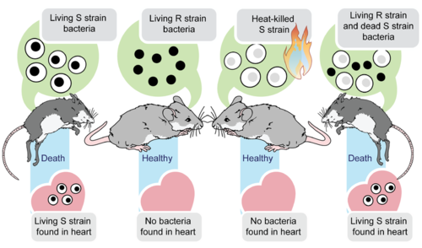

1. What conclusions can be drawn from this study? Support your claim with evidence.
2. What does this experiment tell us about DNA?

**[Oswald Avery, Colin MacLeod, & Maclyn McCarty](http://www.dnaftb.org/17/animation.html)**

This group of scientists extended the research started by Frederick Griffith in *Streptococcus pneumonia* in which they sought to identify the “transforming substance” that Griffith had described in his experiments. The diagram below summarizes the experimental procedure and results. Use this information to answer the following questions.

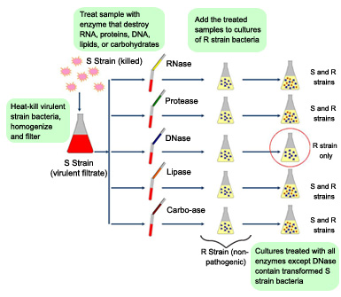

1. What conclusions can be drawn from this study? Support your claim with evidence.
2. What does this experiment tell us about DNA?

**[Alfred Hershey & Martha Chase](http://highered.mheducation.com/sites/dl/free/0072421975/196644/hershey_chase.html)**

After the work of Oswald Avery and his colleagues, there was still doubt about whether DNA was in fact the molecule of inheritance. Proteins were still thought to be a better candidate because they were more diverse in number and structure. Two additional researchers, In 1952 Alfred Hershey and Martha Chase provided additional evidence that was DNA the best candidate as the molecule of inheritance. The diagram below summarizes the experimental procedure and results. Use this information to answer the following questions.

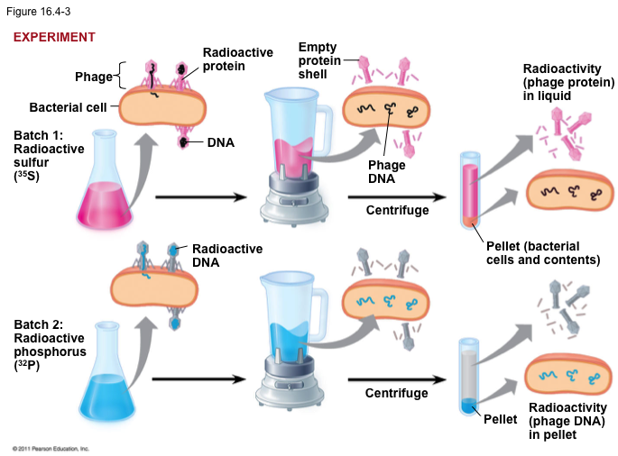

1. What conclusions can be drawn from this study? Support your claim with evidence.
2. What does this experiment tell us about DNA?

**[Erwin Chargaff](http://www.dnalc.org/resources/3d/21-chargaff-ratios.html)**

In 1950, it was already known that DNA was composed of nucleotides made up of a deoxyribose sugar, phosphate group, and one of three nitrogenous bases (adenine, guanine, cytosine, and thymine). The scientific community *still* found it doubtful that DNA was the molecule of inheritance because it didn’t seem possible that only four molecules could encode the complex information of living organisms. Erwin Chargaff contributed another important piece of the DNA puzzle after analyzing the ratio of nitrogenous bases relative to one another within and among members of the same species.

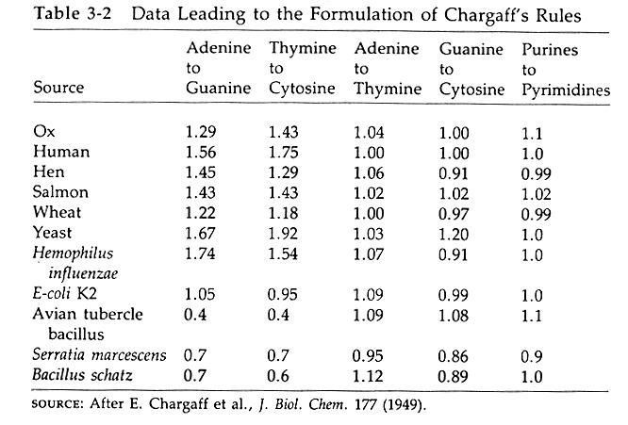

1. What conclusions can be drawn from this study? Support your claim with evidence.
2. What does this experiment tell us about DNA?

**[Rosalind Franklin & Maurice Wilkins](https://www.dnalc.org/view/15014-Franklin-s-X-ray-diffraction-explanation-of-X-ray-pattern-.html)**

**[James Watson & Francis Crick](https://www.dnalc.org/view/16422-Animation-19-The-DNA-molecule-is-shaped-like-a-twisted-ladder-.html)**

In the early 1950’s the scientific community was finally starting to *finally* accept that DNA was the molecule of inheritance. All of the work from the previously mentioned scientists had built a very credible case. However, scientists still disagreed about what the structure of DNA looked like. James Watson and Francis Crick are the ones who ended up receiving all of the credit, but it wasn’t until Watson stumbled upon an X-ray diffraction picture and precise measurements that had been taken by Rosalind Franklin during a visit to her lab.

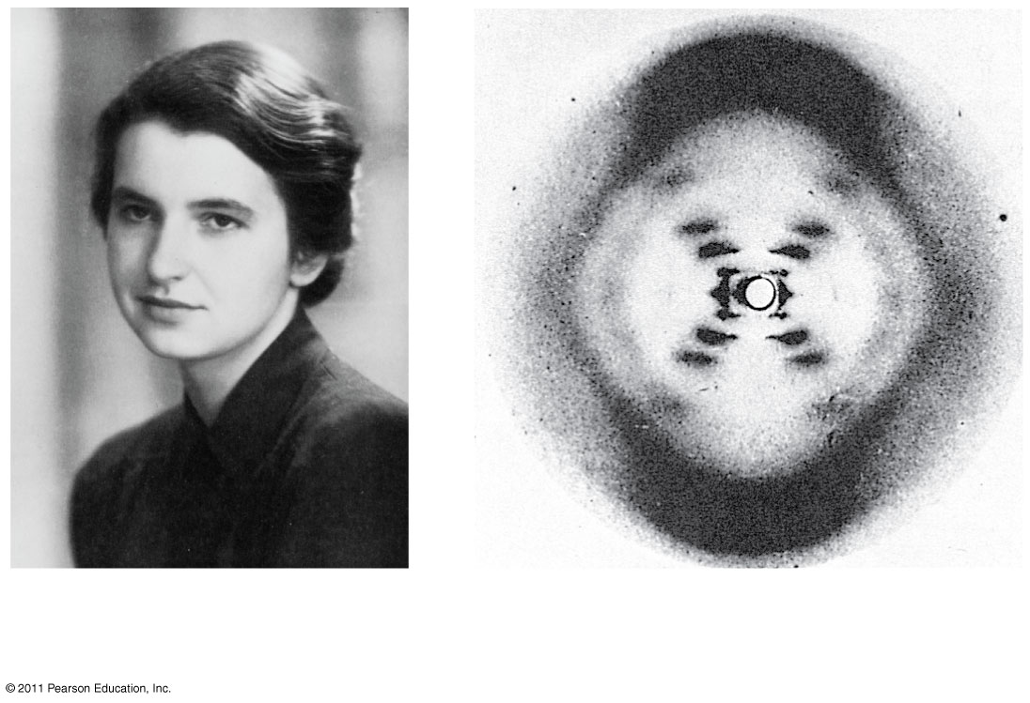

1. What conclusions can be drawn from these studies? Support your claim with evidence.
2. What does this experiment tell us about DNA?